Fast Food Marketing Campaign A\B Test

# **Introduction**

This is an analysis of Fast Food Marketing Campaign A\B Test. A fast-food chain plans to add a new item to its menu. However, they are still undecided between three possible marketing campaigns for promoting the new product. In order to determine which promotion has the greatest effect on sales, the new item is introduced at locations in several randomly selected markets. A different promotion is used at each location, and the weekly sales of the new item are recorded for the first four weeks.

[Data Source](https://www.kaggle.com/datasets/chebotinaa/fast-food-marketing-campaign-ab-test)

# **Goal of the Test**

The main goal of this A/B test is to decide which marketing campaign should be used for promoting a new product.

For the analysis of A/B test results I conducted 3 tests, comparing the three campaigns against one another and i used a confidence level of 99% to reduce the chance of getting a type I error (false positive)

# **Target Metric**

The dataset provides one metric:

* *SalesInThousands*: sales amount for a specific *LocationID*, *Promotion*, and *week*

Since the goal of the AB test was to increase sales, I will use *SalesInThousands* since it aligns with the goal of the test.

Therefore, the target metric of the A/B test is *SalesInThousands*.

# **SQL Query**

**WITH mean_table AS (**

**SELECT**

**location_id,**

**promotion,**

**SUM(sales_in_thousands) AS sum_sales,**

**COUNT(week) AS weeks_count**

**FROM**

**`tc-da-1.turing_data_analytics.wa_marketing_campaign`**

**GROUP BY**

**location_id,**

**promotion**

**ORDER BY**

**promotion, location_id**

**)**

**SELECT**

**promotion,**

**ROUND(AVG(sum_sales) ,2) as avg_sales,**

**ROUND(STDDEV(sum_sales),2) as stddev_sales,**

**COUNT (location_id) as no_of_locations**

**FROM mean_table**

**GROUP BY**

**promotion;**

# **ANALYSIS**

The table contains the numbers necessary to analyze the A/B test and reach a decision.

| **promotion** | **avg_sales** | **stddev_sales** | **no_of_locations** |
| --- | --- | --- | --- |
| 1 | 232.4 | 64.11 | 43 |
| 2 | 189.32 | 57.99 | 47 |
| 3 | 221.46 | 65.54 | 47 |

**Table 1. Summary Statisticsof the three promotions**

I carried out Two-Sample T-Test using [Evan's Awesome A/B Tools](https://www.evanmiller.org/ab-testing/t-test.html)

I calculated Cohen's d value using [Effect Size Calculator for T-Test](https://www.socscistatistics.com/effectsize/default3.aspx)

| **comparison** | **p-value** | **Cohen’s d value** | **Difference of means** | **Standard Error** |
| --- | --- | --- | --- | --- |
| 1 AND 2 | 0.00128 | 0.705 | 43.078 | 12.928 |
| 1 AND 3 | 0.43 | 0.169 | 10.936 | 13.674 |
| 2 AND 3 | 0.0136 | 0.519 | −32.14 | 12.765 |

**Table 2. Summary of 2 Sample T-Test comparing the promotions**

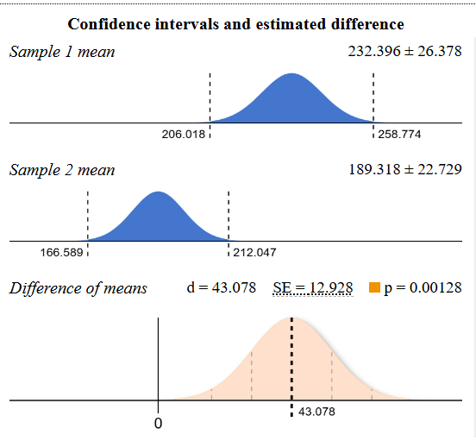

**Figure 1. 2 Sample T-Test comparing promotions 1 and 2**

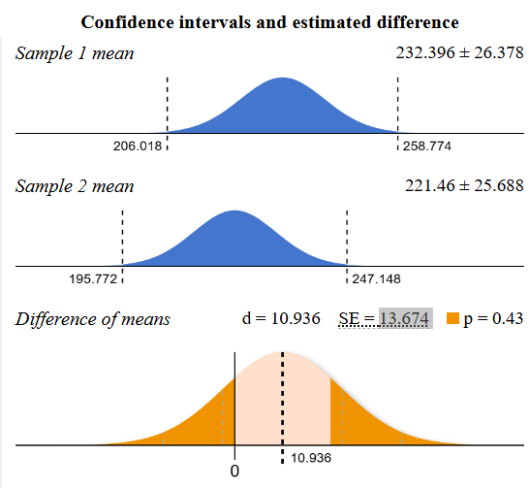

**Figure 2. 2 Sample T-Test comparing promotions 1 and 3**

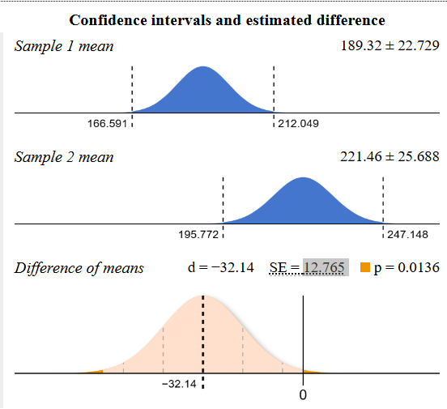

**Figure 3. 2 Sample T-Test comparing promotions 2 and 3**

# **Evaluation**

**p-values:**

* The first and third comparisons have p-values less than 0.01, indicating statistically significant differences between those groups.
* The second comparison, with a p-value of 0.43, shows no statistically significant difference.

**Cohen’s d values:**

d < 0.2 is "trivial effect";

0.2 < d < 0.5 is "small effect";

0.5 < d < 0.8 is "medium effect";

d > 0.8 means "large effect"

* d value for promotion 1 and 2 suggests the difference between these two is medium.
* d value for promotion 1 and 3 suggests the difference between these two is trivia.
* d value for promotion 1 and 2 suggests the difference between these two is medium.

This suggests that the first and third comparisons are important for determining the differences between the marketing campaigns. The second comparison shows that the two groups are not significantly different from one another.

# **Decision**

Choose **Promotion 1** as the most effective marketing strategy for the new item, as it has the highest average sales and statistically significant positive effects.

Avoid Promotion 2, which has the lowest average sales and does not show strong performance. Promotion 3 could be a secondary option but is also less effective than Promotion 1.

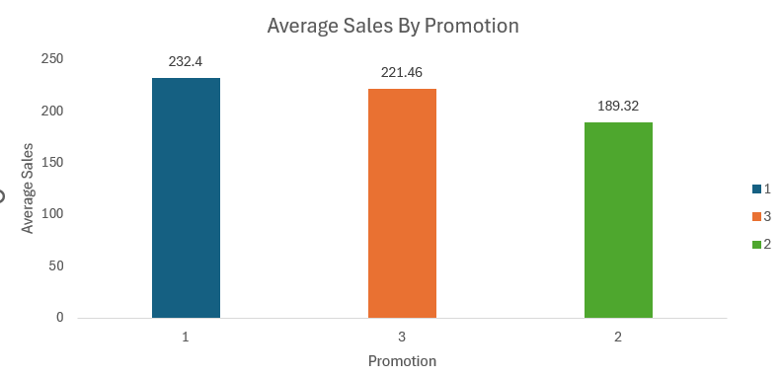

**Figure 4. Average Sales by Promotion**